Use-Case Realization Report (Design)
Add Question

Issue <1.0>
Revision History
Date | Issue | Description | Author
<30/Sep/09> | <1.0> | <Initial version> | <Thomas Yap>

Table of Contents
1. Brief Description 4
2. Flow of Events 4
2.1 Standard Flow 4
2.1.1 Add Question 4
3. Interaction Diagrams 5
3.1 Collaboration Diagram for Add Question 5
3.2 Sequence Diagram for Add Question 5
4. Participating Objects 6
5. Class Diagrams 6
5.1 Class Diagram for Add Question 6
6. Derived Requirements 7

Use-Case Realization Report
Add Question

Brief Description
This use case enables the controller to add new questions to Question Pool. It involves displaying the menu and form for keying in the questions details.

Flow of Events
The standard flow of events for this use case and any exceptions are described in the following subsections. The events are described in terms of Actors and Design Objects.

Standard Flow
This use case covers the Question Maintenance - Add Question. The standard flows of these events are described below.

Add Question
The running of the application is shown in section 3.1. The flow of event is as follow:

- When the application start, the first operation to be performed is the startup operation of the main controller. This operation will create all the control objects and the entity objects necessary for operation Add Question:
  - The control object created is: MCQBL Controller
  - The entity objects create are: mcq_exam_master, mcq_section_master, mcq_question_master and mcq_question_option

- The main controller will start the main function menu:
  - To start Add Question, operation page_load() is activated by MCQBL to display a question form.
  - Portal Admin then input the data.
  - Operation validation will validate the format of the entries.
  - Then MCQBL controller will check for duplication.
  - If no issue found, MCQBL Controller will send a confirmation request to form Question Interface.
  - Upon confirmation, the data will then be written to table using operation InsertQuestion() and InsertQuestionOption() to entity object mcq_question_master and mcq_question_option.
  - The adding request can be cancelled by clicking cancel button and no data will be stored.
  - A confirmation message will be displayed by form Question interface.

- Step 2 will be repeated until all new entries are added to the system. Then controller will terminate the application by issuing operation close.

Interaction Diagrams

Collaboration Diagram for Add Question
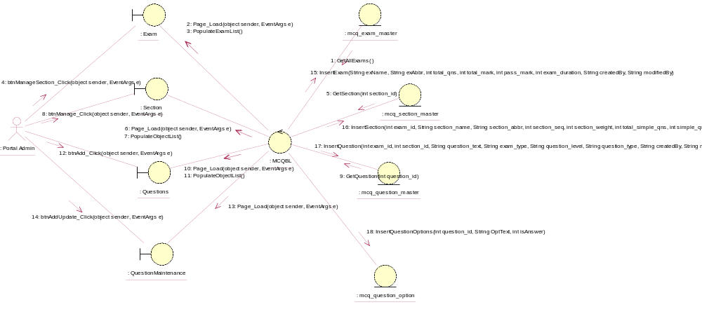

Sequence Diagram for Add Question
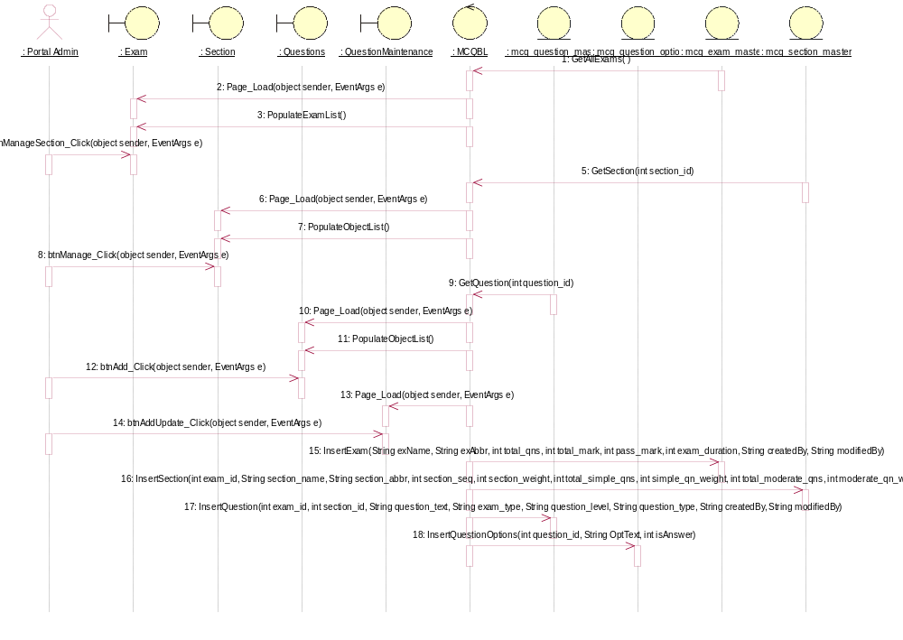

Participating Objects
: Exam

: mcq_exam_master

: mcq_question_master

: mcq_question_option

: mcq_section_master

: MCQBL

: Portal Admin

: QuestionMaintenance

: Questions

: Section

Class Diagrams

Class Diagram for Add Question
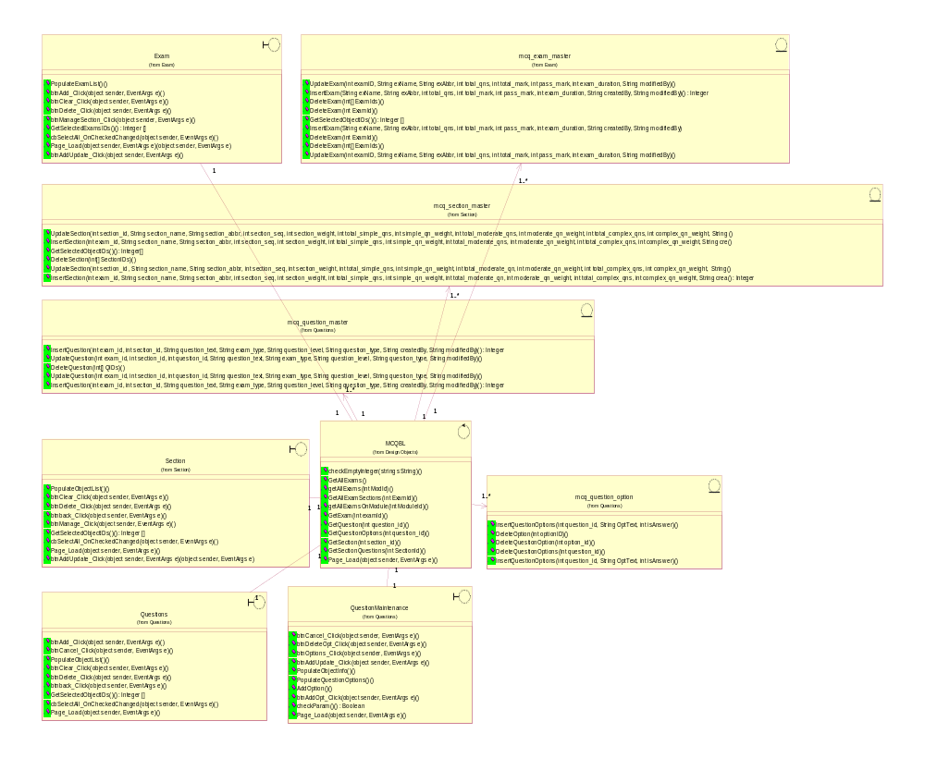

Derived Requirements
[enter the derived requirements here]

